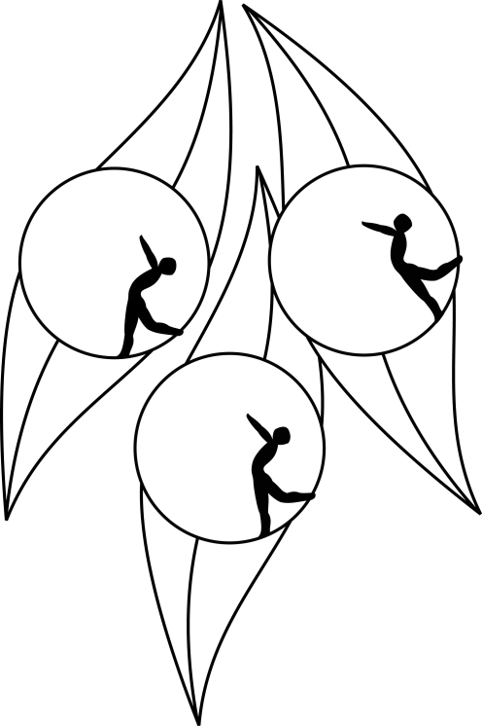
SOUTH AUSTRALIAN ICE SKATING ASSOCIATION Inc.

Results

TEST SESSION

6 February 2011
Ice Arena, Thebarton

Congratulations to the following skaters:

Elementary Figure Pattern
James Min

Elementary Dance
Callum Bradshaw

Pre-Primary Technical
James Min

